How to Build Your Own Amazon Echo Skill: Overview and Planning (Part 1)
In this series of articles, we'll deep dive into possible use-cases for Alexa Skills, show the basics of how they work, provide info on the testing process, and walk you through the practicalities of publishing your skill

by Joshua Porter Dec. 19, 16 · IoT Zone · Tutorial
https://dzone.com/articles/how-to-build-your-own-amazon-echo-skill-overview-a

In this series of blog post, we'll deep dive into a couple different use-cases for creating Alexa apps (known as “Skills”). As part of this series we will go over the basics of how they Alex skills work, provide info on the testing process, and walk you through the practicalities of publishing your skill.

This series will be delivered in four parts and is going to take the following format:
- How and Why You Should Build Your Own Amazon Echo Skill: Overview and Planning
- How to Build Your Own Amazon Echo Skill: Building It
- How to Build Your Own Amazon Echo Skill: Testing and Customization
- How to Build Your Own Amazon Echo Skill: Publishing and Tracking User Behaviors
I hope you enjoy it!

Part 1 - Building your own Amazon Echo Skill: Overview and Planning
We strongly believe that asking people to use voice commands to activate your product features or explore more of what you have to offer is a very powerful way to find new customers or build engagement with your existing customers.
Let me dive into a few real-life examples of how you might use Skills...
When a user issues a voice command to use some primary feature of your product, you could also add a call to action at the end to nudge users into taking another high-value action.
High-value actions might include things like:
- Subscribing
- Making a purchase
- Referring friends
So, an example for a media brand may play out like this:
- User: “Alexa, give me the latest news from the New York Times”
- Alexa: “Here are today’s top stories….For unlimited access to our in-depth coverage of world events, you can subscribe at {shortened url}.”
An example for a freemium app, like this:
- User: “Alexa, play {Song} on Spotify.”
- Alexa: “To enjoy all your songs offline without ads, you can upgrade to Spotify Premium for only $X/month.”
And, an example for an e-commerce business:
- User: “Order {Item} on Amazon.”
- Alexa: “Would you like to order with 2-day free shipping?”
Most people think developing a skill for Alexa (in other words, teaching Alexa to perform a task) is something which can only be done by some tech geniuses or engineers with extensive experience in the field. That’s not quite the case.
If you are somewhat technical and have written some code before, you can learn how to build an Alexa Skill.
By the end of this 4-part article series, you will make a fully functional Alexa skill, teaching Amazon Echo to perform a task for yourself.
Ready? Well, let’s roll on with Part 1.
By this point in the article, I’m sure you understand the value of creating an Alexa Skill. Now, let’s look at an overview of how to do it.
XXXXX

What You’ll Need to Get Started
- Amazon Echo (which you can build on your own for much cheaper than what it sells for on Amazon.)
- A laptop or desktop, a regular Macbook would usually do the job.
- An account on GitHub.
- A bit of time, see below how long it takes to build a skill.

How Long Does It Roughly Take to Develop
Skill Type | Description | Planning | Coding | Testing / Deploy | Total
Smart Home Skill API | Voice command cloud-connected home devices  Example: Voice command to turn off the lights | 5 days | 5 days | 5 days | 3 weeks
Flash Briefing Skill | Voice command to receive the most recent content or news  Example: Voice command to hear the latest world news headlines | 5 days | 5 days | 5 days | 3 weeks
Custom Skill | Voice command to activate a custom response  Example: How do I make an omelet? | 10 days | 15 days | 5 days | 6 week

Overview of the Steps and What You’ll Need to Get Started
- Sign up for the following free accounts
  - Create a free account as an Amazon Developer and name your skill.
  - Create a free account at Lucidchart so that you can draw workflow diagrams create diagrams

- Build your interaction model (this is just a fancy word for a visual diagram of how you want Alexa commands to work and Alexa to respond).
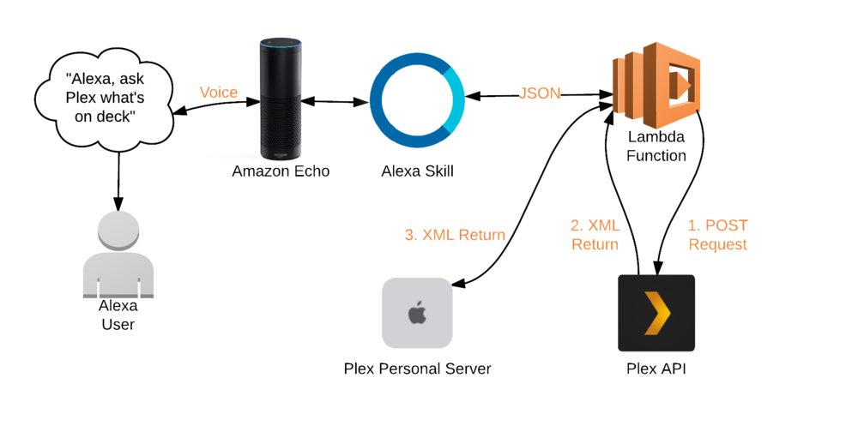
- Upload your code into AWS Lambda to set up your Alexa skill.
- Configure and test your code.
- If building an Alexa Fact Skill, add custom facts into the code.
- Publish your skill.

Step One: Map Out Your User Commands and Response Paths
Start off by mapping out the different response paths a voice command could activate depending on contextual cues including the time of day and the user’s location. A good mapping tool is Lucid Chart.
Here’s an example of a response path map for a wellness product:
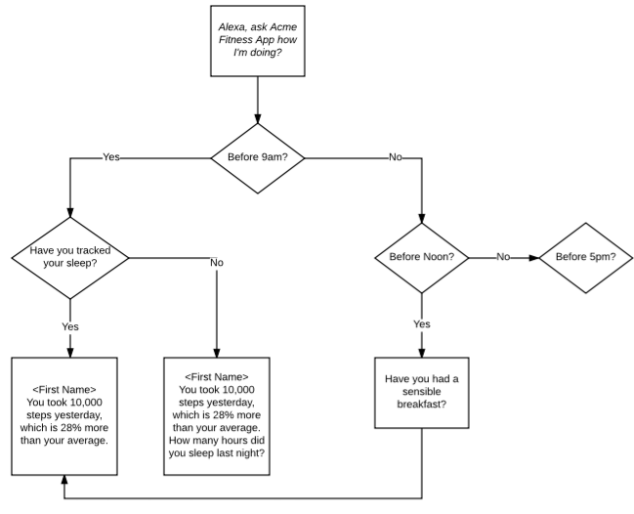

Action Item for Building Your Amazon Echo Skill Part 1
Map out all the possible response paths your user voice command could activate related to your product.

Build Your Own Alexa Skill
We've written up the above secrets as part of a free help guide on designing your own Alexa Skills. You can download it here:
How to Build your First Amazon Alexa Skill

How to Build Your Own Amazon Echo Skill: Building It

How to Build Your Own Amazon Echo Skill: Testing and Customization

How to Build Your Own Amazon Echo Skill: Publishing and Tracking User Behaviors

